Learning to Worship & Create, The Best Wine Last
March 1, 2017

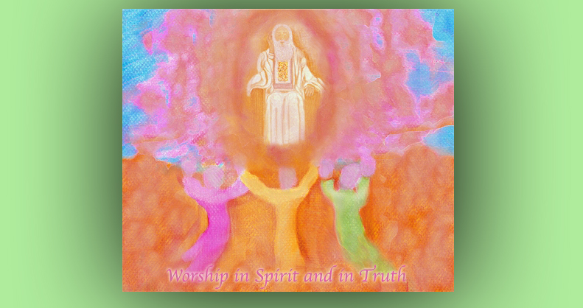
May the sweet Fragrance of Jesus be released from our hearts as He draws us deeper and deeper into His Love.

As I came into worship today, I noticed the Lord was dancing with the worship song that I was listening to. And I began singing to that song. And I just felt such a wave of sweetness come over my spirit when I began to do that. I realized that this, in part, is what the Lord is answering our prayers with: the be worshipful from the heart while creating.

So, I asked Him, 'Lord. What's on Your heart today?'

And He said, “Dance with Me. Dance with Me, Clare, and allow the joy of our love to permeate your very being.”

I have been seeing Him dancing with me to worship songs. But I think I’ve been a little guarded.

“A LITTLE!!” Jesus exclaimed, “That’s an understatement. You have nothing to be ashamed of, nothing to be afraid of, and every reason to rejoice in this season of your life. And I do intend that it will get better and better, like a fine wine. Is that not the Scripture verse I gave to you and Ezekiel?”

“He has saved the best wine for last.” John 2:10”

And that's from the story of the wedding supper. This was the first miracle the Lord did. He was attending a wedding and the groom ran out of wine for his guests. Very embarrassing situation! And interestingly, he didn't do anything about it.

But then, His mother came to Him and she said, 'Son - they've run out of wine.' And He went and performed this miracle, turning the water into wine. And when the wine was served, the guests said, 'This wine is better than the first wine! Usually people wait until we get drunk, and then bring out the cheap wine.' It was a beautiful, beautiful request to her prayer - her intercession, really. That situation.

So, the expression 'He saved the best for last.' is referring back to that episode in John the 2nd chapter.

The Lord continued, "I follow closely the life story of all My children and so many had very hard beginnings, and have been worn out before their time. That is when I bring out the BIG surprise: blessings beyond what they ever expected out of a life so filled with sorrow and failure.

"Are you not a good example? While others who have seen their seasons of success early in life are growing older, you two are growing younger with horizons full of hope. I delight in doing this.

"The devils think they can wear you down and make you useless as you get older, but I say, 'Think again. I am the God of new Mercies every morning, new beginnings, and rebirth.' Being reborn calls for an entirely new and hopeful life. Time to leave sad stories of defeat behind and step into My New Mercies. “Every time we step onto a new plateau together, it is time to refresh that original rebirth into My Kingdom.

"This is why I am asking you to dance with Me. Sing to Me. Let our hearts be entwined in the joyous celebration of our love for one another and our children. Sing to Me from your heart beloved, ‘Your mouth is an excellent wine.’ Song of Solomon 7:9"

I was quite amazed at your response to my singing - it was so…

“Sincere," He said. "That’s what captured My Heart. No matter that your voice wasn’t warmed up - warm it up on Me Beloved, warm it up on Me! As long as it is from your heart in utter sincerity, I am delighted beyond words. It ministers to Me, Clare. Do you understand?

"Abandon technique and concentrate on the connection we have, heart to heart. You will be amazed that your voice will adjust itself into perfect pitch without your effort. You see, when you worship in spirit and in truth, I make all the corrections necessary. Your only effort should be in the area of ignoring every other thought than this one: 'Oh My God - I love you!' The rest I will make happen.

"We are on a journey now, Beloved. You have asked Me to teach you how to worship and sing from the heart, and that’s precisely what we are doing, together. We sing beautifully together. You reach out to Me in worship and My Heart comes bounding back in appreciation and with it the anointing to make every necessary adjustment, bringing it into perfection. But not through technical expertise - through love; pure worship and love."

I was singing some Julie True’s songs to the Lord earlier and was so amazed when His heart responded with such tenderness and appreciation, like a wave of sweetness washing over me. By this I knew that, somehow, I had entered into worship that was pleasing to Him.

Jesus continued, “The piano is coming. It is coming along nicely. Continue to practice and allow yourself the freedom to experiment. Nothing is more boring than the same old thing over and over again. I have given you liberty, so you can enjoy freedom, as well as finishing the song."

But Lord, you give me so many wonderful melodies that I just keep writing songs…and not getting them out.

“That is in the process of changing. Yes, work on one at a time, but you need freedom to play as well. And I rejoice in your freedoms. Please don’t envision Me as a harsh task master, looking over your shoulder 24-7 and asking, 'Where’s the song? Why isn’t it finished?' You and I both know why it’s not finished - but it will be soon."

Is that a promise, Lord?

"It is."

He is talking here about a song He gave me 3 weeks ago, that I still haven’t finished ironing out the wrinkles on...but I’m getting close. There is yet one verse that needs rewording and some coordination issues in playing it, then I can put it up for you.

The title of the song is: LORD Have It Your Way
(Clare sings:)
You are beautiful
oh so beautiful
My Heart’s in Your hands
Oh take all of me
till nothing more is left
only You.

You are holy
oh so holy
nothing in this world can hold me
Every malice
my heart so callous
fades away before Your presence

The second verse is:

Lord I cherish You, cherish You
please have it your way,
just one glance from you
is all I need to pray, “Have it your way.”

So that kinda gives you an idea of what the song is like. As you can tell, I'm dealing with self-will here. And that's, I think, why the Lord gave me this song. To help me deal with it. Because it's His sweetness, His kindness, His love and His presence that makes us want to change! And so, that's really a key-note of the song.

The Lord continued, "Rest assured. It is coming along. And even better than this, with each song it will get easier. Right now you are facing a hurtle of unbelief and doubt. 'Can I do this?' The answer is NO, you can’t. 'But through You, I CAN.'

"When your eyes are on Me, Clare, and Me alone: not your fears, not your doubts, not your wobbly voice, but on Me. In LOVE with ME - yes, you can. This is why I want to dance with you. I want you to feel My confidence in you, My affection and that I believe in you. That we, as a couple, can do this.

"Oh, My children, so many of you have had dreams that were aborted by life circumstances. The enemy has tried to close your case and stamp you 'FINISHED'. But I say rubbish to finished. You still have breath in you and what you are lacking I can breathe into you afresh each day. Only one thing really is required, faith in ME. And that when I give you My Word, it is My Word, and I back it up.

"It takes so little, dear ones. It looks like a big black monster lurking in the corner throwing out crude and debilitating comments, 'WON’T WORK. GIVE IT UP. GET REAL. YOU HAVEN’T DONE THE DISHES YET. WHAT ABOUT THAT PHONE CALL YOU PROMISED. YOU ARE TOO OLD…YOU JUST DON’T GET IT DO YOU? FACE IT, YOU’RE A FAILURE.'

"No, you are not the failure here. Satan is the failure, that’s his byline. And typical of all those in denial, he projects that onto My children - if they will have it. But you are NOT to have it. NOT to go into agreement with his lies. The truth is, I can do anything through anyone who is willing and has faith in Me. And if their faith is wavering? I can fix that, too. Consent is the bottom line. With your consent, I go to work fixing every impediment to your success.

"So I am asking you, don’t be cowed by the liars.

"Trust in the LORD with all your heart, And lean not on your own understanding; In all your ways acknowledge Me., And I shall direct your paths. Proverbs 3:5-6

"And I shall direct your paths... successfully, I might add. In other words, when we have a goal together, no matter what it is, we will succeed together, if you don’t turn back.

"So, go forth My glorious Brides and let us bring into being all I have given us to do."

